**Instructions to run Eclipse and use Junit tests**

You will be provided with the following resources:

1. Question paper: A document that describes the overall goal of the program that you are writing.
2. Eclipse Skeleton zip file: This is the Eclipse project skeleton which you have to work on. It will be called Lab0 and contains the bin,doc,src folders. It is a zip file.
3. Test jar: **A Java file for running unit tests (Not a JAR file).**
4. Javadoc: These are contained in the doc folder inside the Eclipse project skeleton. This is a complete java documentation of the classes and methods that will be designed by you.

Files that are given to you are:

1. **Lab2.zip** : This is the Eclipse project which contains the basic java files.
2. **SolutionTest.java**: This file contains all the test cases to test your Java code.

STEPS: This will be discussed in Lab 0, but here are the screenshots for quick reference.

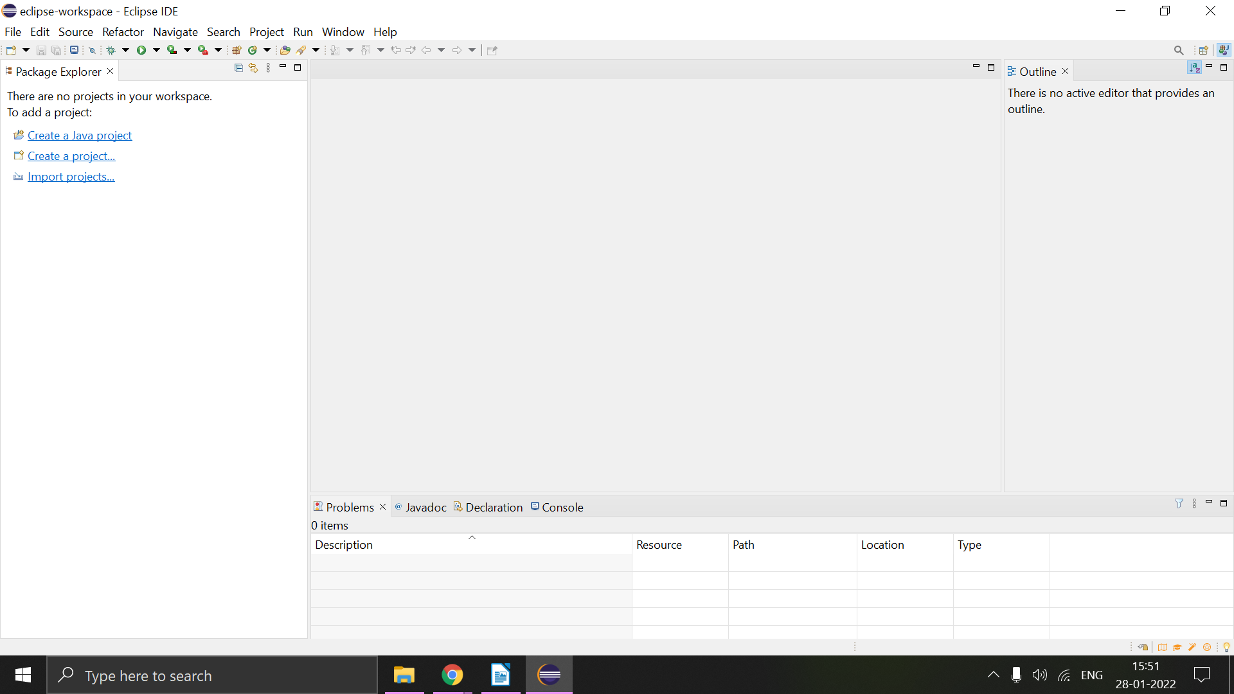

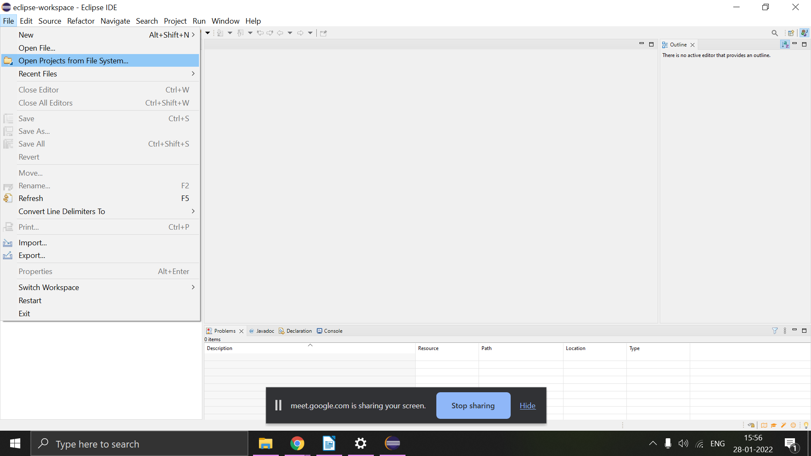

Select archive and import the Eclipse Project given to you**.**

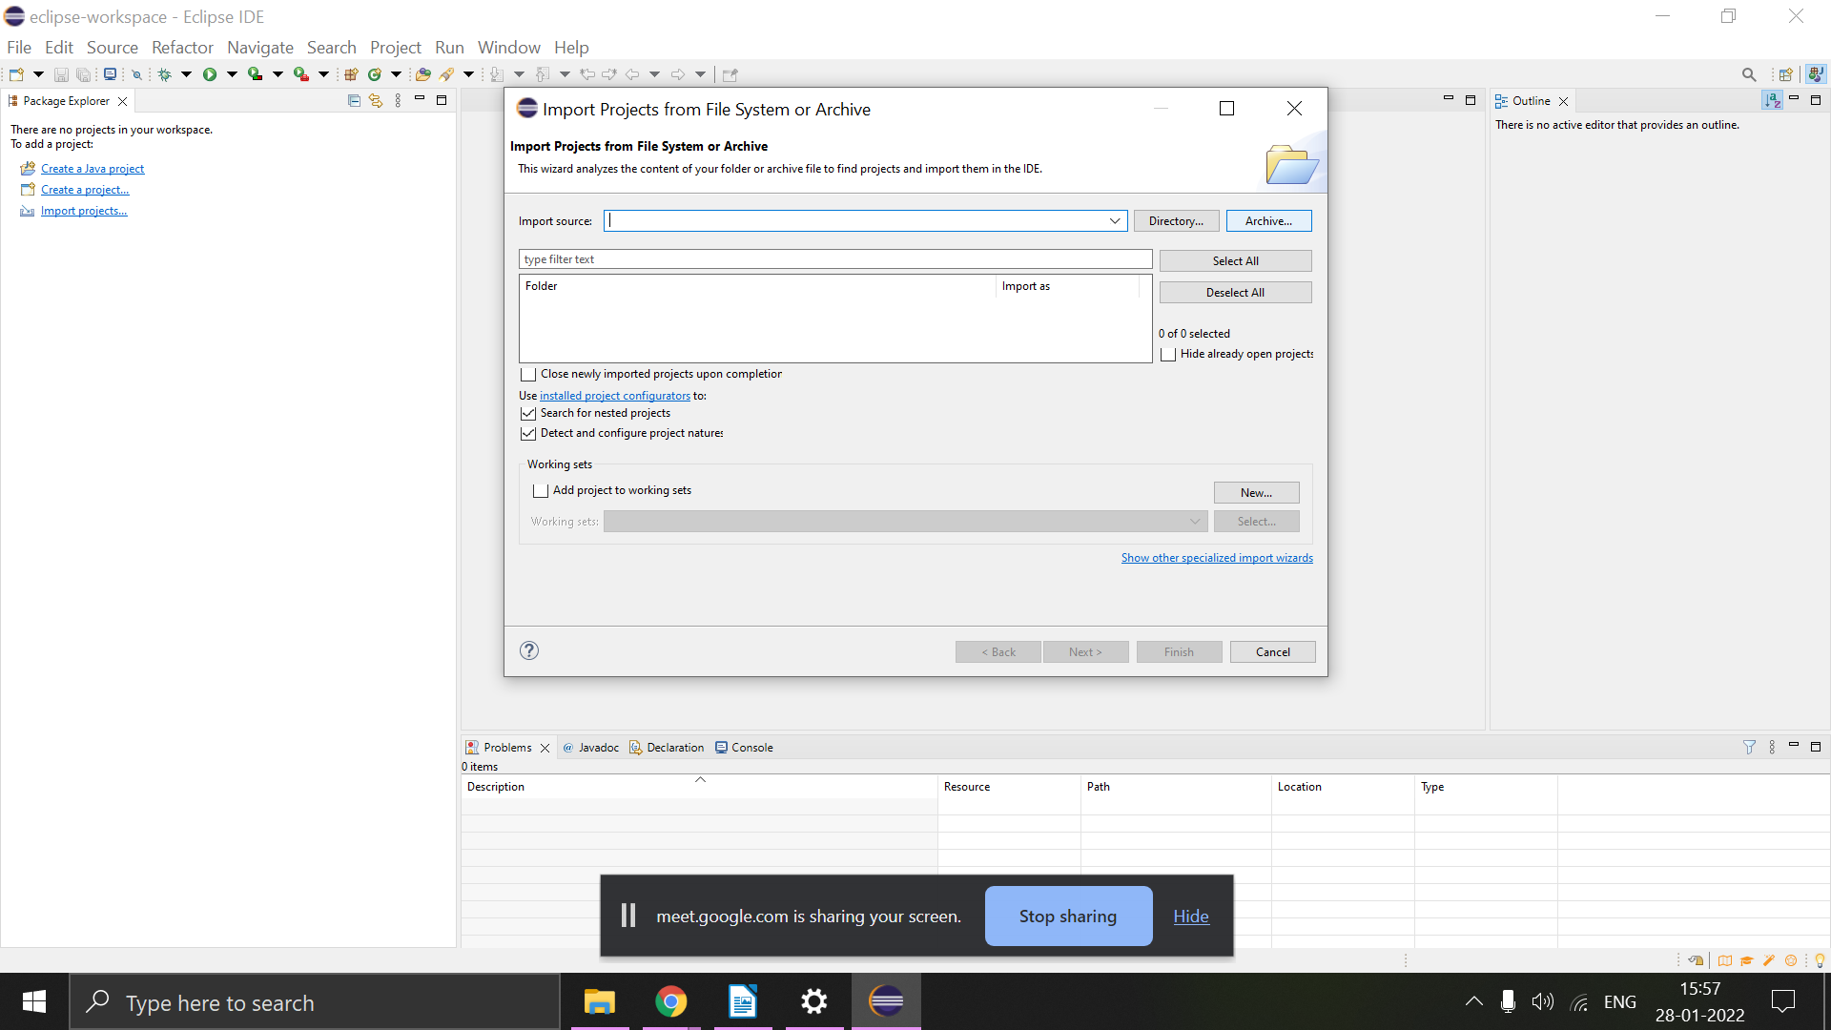

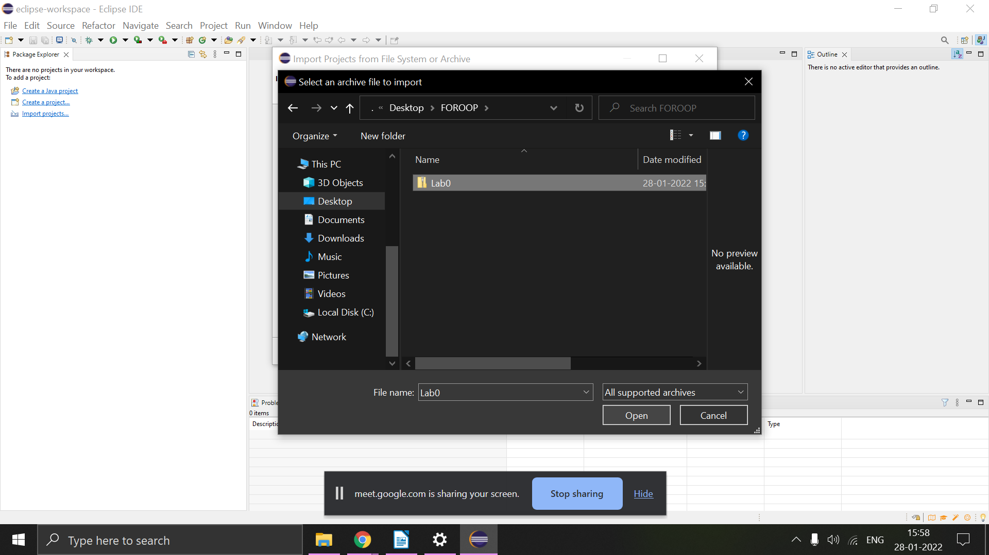

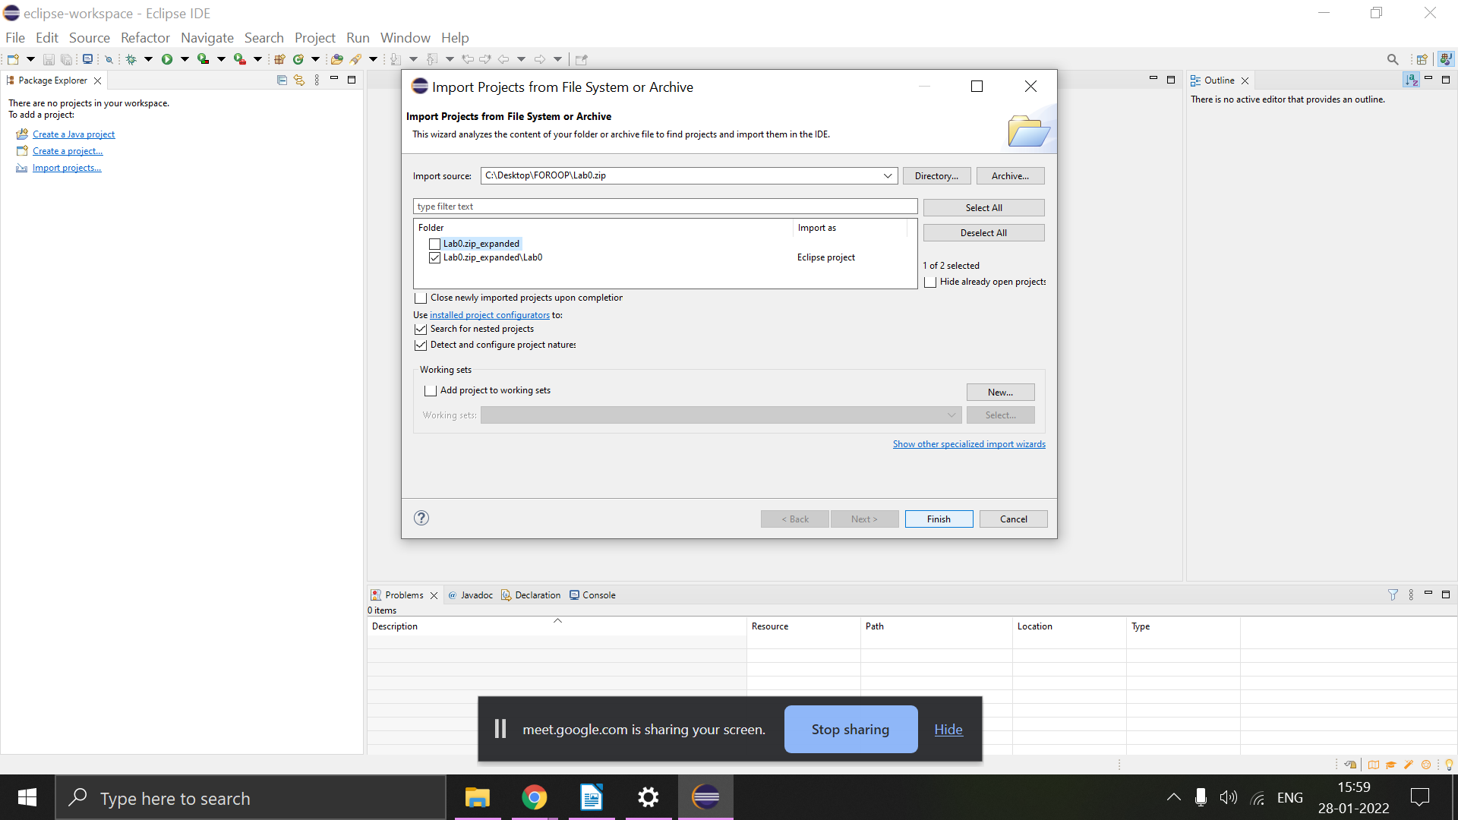Make sure to untick the first check box in the image above.

Now, you should see the project in the package explorer.

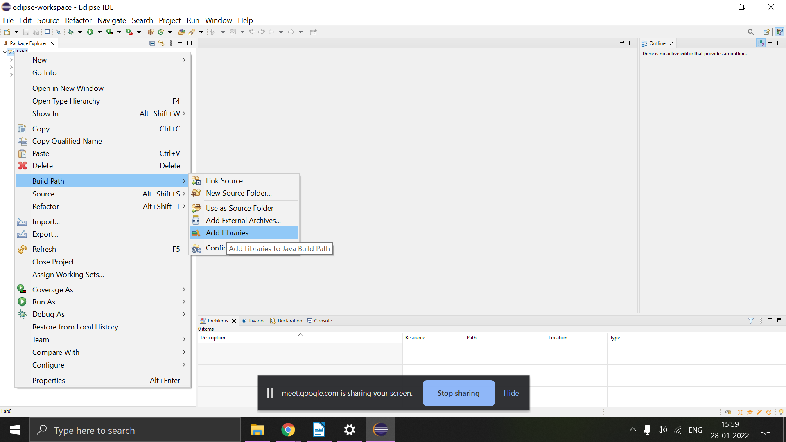

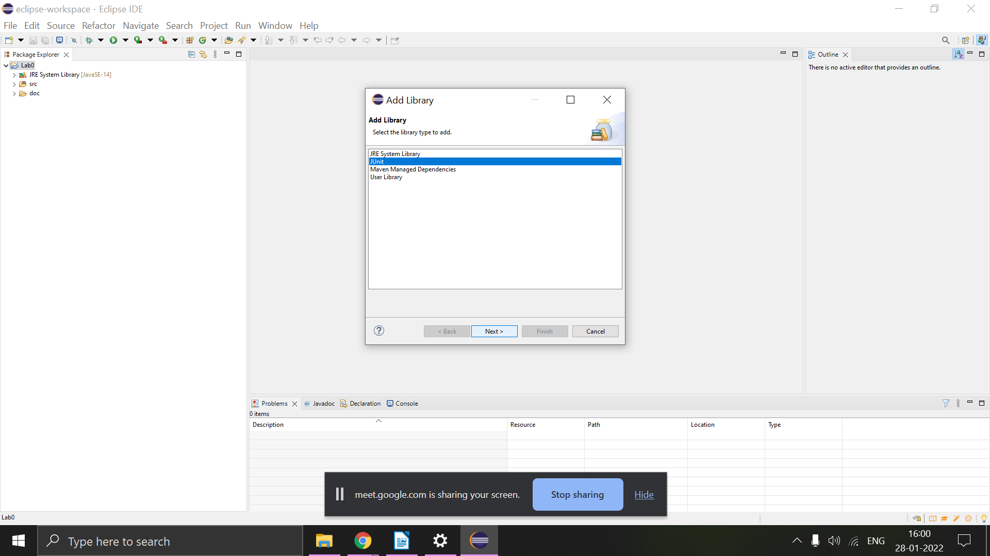

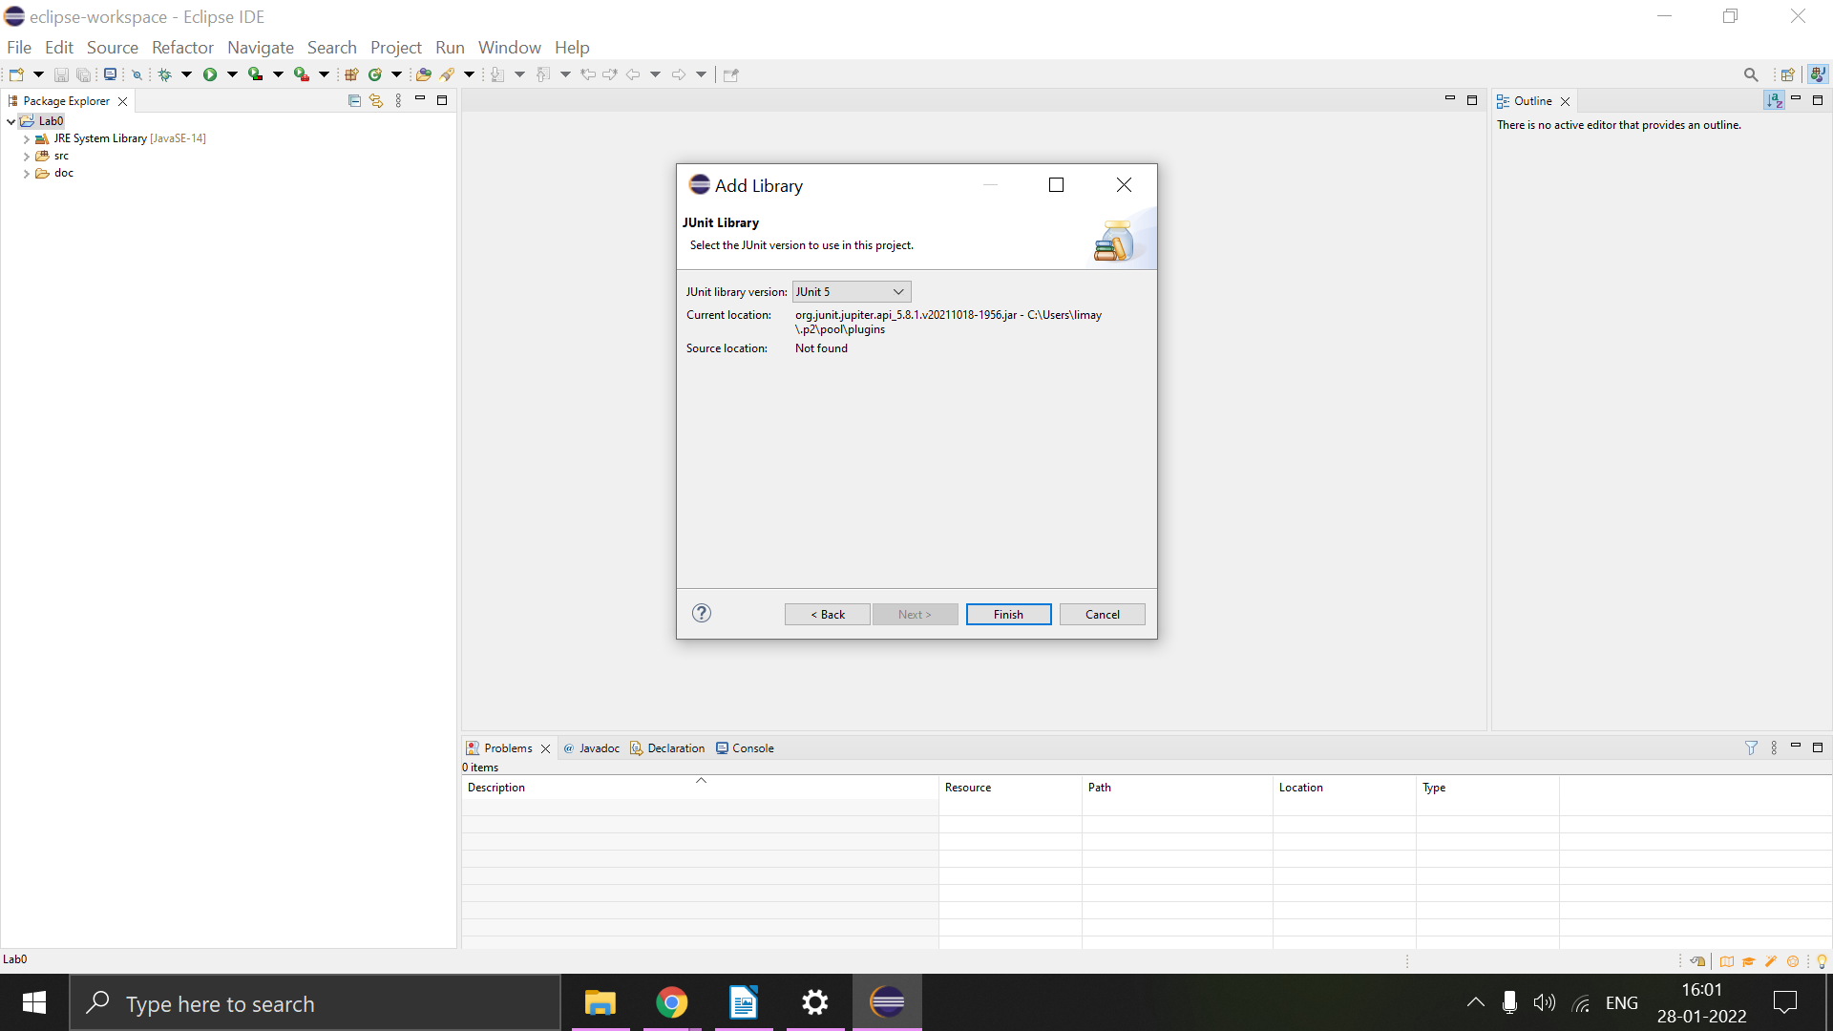

* **Instead of importing .jar as external archive, after adding Junit 5, right click on the SolutionTest.java file and click Run As -> Junit test.**
* **This in turn runs the tests just as it would normally with a JAR file, only that now you can see the tests as a Java file as well.**